Week 1

01/16/2026
The group met with Dr. Kim to discuss potential project ideas (robotic arm, zebra fish, physical therapy device). He was not convinced on any of the ideas. Later that day Sebastian thought of the Reactive Robot and the team decided to do that.

Week 2

01/23/2026
The group met to figure out parts and what we want to work on this weekend. The GANTT chart will fall into place after that. Insert picture of the whiteboard below. It was a picture of the robot arm with 3 joints. The robot arm microcontroller needs to be separate from the sensors/object detection microcontroller (so basically separate hardware). And anish will model the blender and simulink stuff for the presentation. Elizabeth and Ariana are responsible for finding a robot arm for the project (ideally one that can be 3D printed).
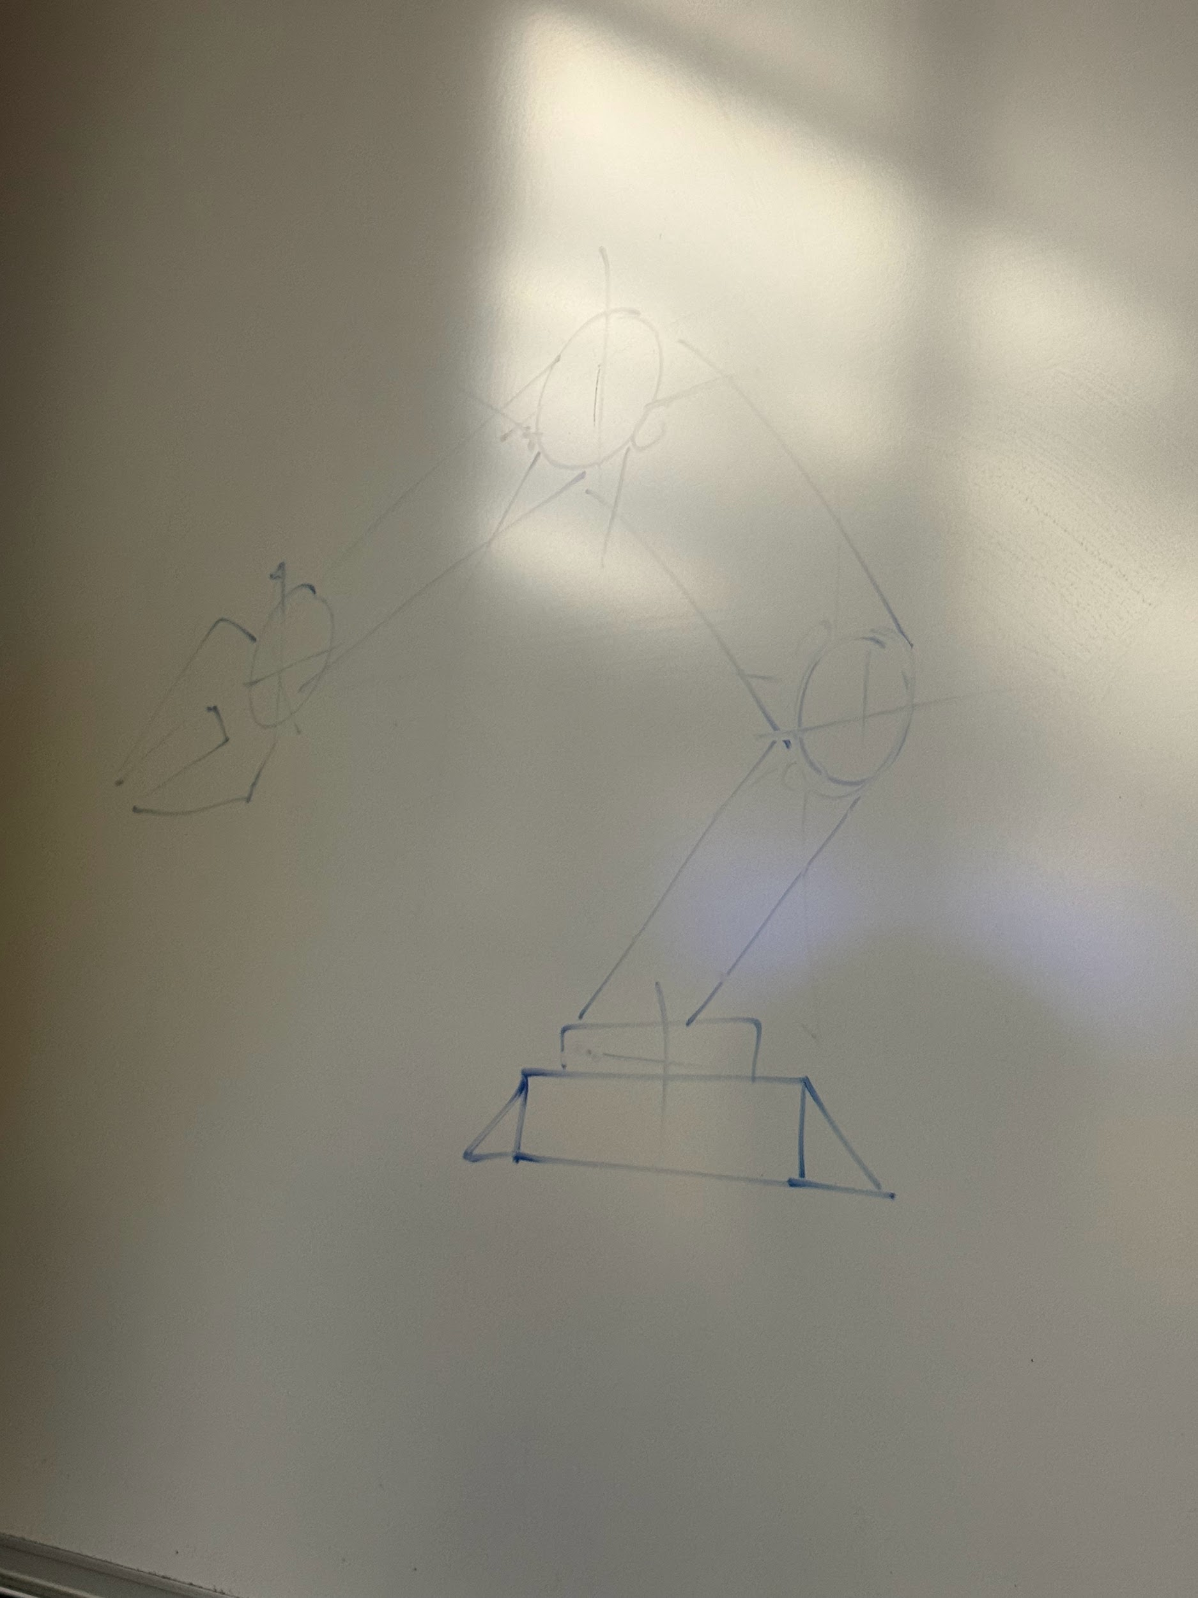

1/23/2026-1/25/2026
Ariana researched possible robotic arms and made a document with 7 options.

Week 3

1/26/2026
The group met to discuss which robotic arm they would like to build and the types of sensors that would work best for this project. Additionally, decided on servo motors to make inverse kinematic equations easier (instead of using steppers+encoders)

1/27/2026
Elizabeth downloaded Fusion CAD software and learned how to scale robotic arm parts to lengthen the arm.
Sebastian tested a time-of-flight sensor that turned out to not work. He ordered more in hopes of finding a working sensor (est. Thur/Fri)

1/28/2026
The group met to discuss the project. Discussed time of flight sensors and decided to stick with the robotic arm: Compact Robot Arm (Arduino) - 3D Printed by BuildSomeStuff. Arm pieces will be lengthened to make it more realistic for application.

1/29/2026
Ariana filled out the Gantt chart planning the tasks needed to complete the project week by week.

1/30/2026
The group met during the lab. While the team tested the modified PCB, Anish started a GitHub repository for the project. He also looked into some online resources for modeling the arm in Simulink. Since we’re using AutoDesk Fusion, I think this is good for what we want the data to look like when we export from Fusion.I also found this chinese article on what someone did with fusion. Discussed the possibility of using NameCheap Student Github Development Pack for a 1-year free domain for the project website (need to link GitHub with student email to get it). Invited Ariana and Sebastian to the github

Week 4

2/1/2026
Elizabeth developed parts list with quantities, pricing and links for the project. Elizabeth also worked on the Abstract for the Research Symposium.

2/3/2026
Ariana downloaded AutoDesk Fusion, project files, and started working on increasing the size of the robot arm.

2/4/2026
Group met and discussed formal proposal. Anish and Sebastian finished the hardware and software block diagrams. Tasks were assigned to team members according to the gantt chart. Discussed hardware necessary for for time of flight sensors.

2/6/2026
Added finishing touches to formal proposal. Anish added more body and references to the literature review portion of the proposal. Elizabeth realized using stepper motors for the base of the arm is not as beneficial as we thought it would be. Stepper motor does not provide enough torque for the robotic arm specifications, so a high torque servo motor with 270 degrees of motion will be used for the base instead. Also, an already constructed robotic arm was found in the lab and Sebastian was going to test it to see if it works. Ariana worked on lengthening the arm pieces of the 3d printed robotic arm on fusion and learned how to use the 3d printing software.

Purchased Arduino Braccio to streamline robot arm development from a reliability standpoint with known dynamics instead of relying on 3D printed parts prone to failure. Determined goals for demoing, the arm performs a periodic side-to-side movement and an obstacle is put in its path. Designed framework to extract position data from servos by soldering a wire to its internal encoder to extract real-time position data for control system development should it be necessary, designed analog impedance decoupling circuit using op amps and low pass filter with PCB designed and ready to send to manufacturer. Begun development of Inver Kinematics algorithm leveraging open-source 3D model of the Braccio. Finalized parts list sent to Dr. Siddiqui for acquisition.

2/15
Elizabeth designed sensor mounts for the IR sensors in Fusion based on amazon parameters.

2/20
Ariana and Elizabeth figured out how to use 3d printer, and test printed a tof sensor mount as well as the IR sensor mount they designed. Found that the TOF design was correct, however the IR mount was too small, so Elizabeth made further adjustments.

2/27/2026
Anish worked on expanding the inverse kinematics implementation to each servo motor. He also captured videos and pictures of the robotic arm in operation and completed his assigned presentation slides, including Program Flow, Project Implementation, Deliverables, and Conclusion.
Sebastian focused on soldering the ToF sensors and successfully developed a working sensor model. He also completed his midterm presentation slides covering the Hardware Block Diagram, Implementation, and Initial Project Results.
Ariana improved the ToF sensor mount design by adding support pillars for the mounting screws to increase stability. She also worked on the Background and Project Goals slides for the midterm presentation.
Elizabeth ensured that all team members had their assigned slides and checked in on each member’s progress within their respective roles. She also completed her presentation sections, including the Introduction, Gantt Chart, and Main Challenges.

